AD LIFECYCLE ARTIFACT | External Design Document – V4.0  High Level Design
Application: OMS: Place an Order | Project Name: InfoScan MK
Author: Gary Sanders | Project Code:
The External Design represents the high level functional specifications for the application based upon the approved business requirements.
1. Document Version Information 4
2. Release Notes 5
External Design Document Version 1.0: 07/17/05 5
3. Introduction 6
Naming Conventions 6
Field ID’s 7
4. Requirements Traceability Matrix 8
Place an Order: Create an Order V1.7 8
Place an Order: Update an Order V1.7 9
Place an Order: Search and Compare V1.5 9
Place an Order: Cancel and Order V1.4 10
Place an Order: Delivery Management V1.5 10
5. Design Assumptions 11
6. Design Limitations 12
7. Design Risks 13
8. Significant OMS Constructs 14
Dimension Option Classes 14
Dimension Option Items 14
Orders 14
Order Statuses 14
Order Versioning 15
Orders 15
9. High Level Summary of Screens and Functionality 16
High Level Screen Flow 17
Standard Tabs 18
User Roles and Roles Based Functionality 19
Concurrent Activity and Conflict Handling 20
Internationalization 20
10. Screen M01: OMS Authentication Screen 21
Authentication Screen Fields and Functionality 21
Authentication Screen Mockup 22
Under the Hood: Authentication Service and Role Mapping 23
11. Screen M02: OMS Home Page 24
OMS Home Page Fields and Functionality 24
OMS Home Page Mockup 25
12. Screen O01: Order Create Screen 26
Order Create Screen Fields and Functionality 26
Order Create Screen Mockup 27
13. Screen O02: Order Configuration Screen 28
Order Configuration Screen Fields and Functionality 28
Configuration Panes 28
Option Item/Class Pane 29
Configuration Summary Pane 29
Model Dimension Option Classes 29
Order Configuration Screen Fields and Functionality 30
Order Configuration Screen Mockup 32
14. Screen O03: Order Search Screen 33
Order Search Screen and Functionality 33
Constant Search Fields 34
Order Level Search Fields 34
Dimension Group Level Search Fields 35
Order Search Screen Mockup 35
15. Screen O04: Order List Screen 36
Order List Screen Fields and Functionality 36
Differences In between Draft and Committed Orders 36
Order List Screen Pagination Functionality 39
Order List Screen Sorting Functionality 39
Order List Screen Mockup 40
16. Screen O05: Order Detail Screen 42
Differences In between Draft and Committed Orders 42
Order Detail Screen Fields and Functionality 43
Order Detail Screen Mockup 47
17. Screen O06: Draft Order Version History Screen 49
Draft Order Version History Fields and Functionality 49
Order Version History Mockup 50
18. Screen O07: Order History Screen 51
Order History Screen Fields and Functionality 51
Order History Screen Mockup 51
19. Screen D01: Order Delivery Search Screen 52
Order Delivery Search Screen Fields and Functionality 52
Order Delivery Search Screen Mockup 54
20. Screen D02: Order Delivery List Screen 55
Order Delivery List Screen Fields and Functionality 55
Order Delivery List Screen Mockup 59

Table of Figures

Figure 1: OMS Screen Flow 17
Figure 2: OMS Authentication Screen 22
Figure 3: OMS Home Page 25
Figure 4: Order Create Screen 27
Figure 5: Order Configuration Screen 33
Figure 6: Order Search Screen 36
Figure 7: Order List Screen – Draft Orders 41
Figure 8: Order List Screen – Committed Orders 41
Figure 9: Order List Screen – Order search 42
Figure 10: Order Detail Screen: Draft Order 48
Figure 11: Order Detail Screen: Committed Order 49
Figure 12: Version History Screen 51
Figure 13: Order Delivery Screen 55
Figure 14: Order Delivery List Screen 60

Document Version Information

Document Version Information
Version | Description of Changes | Date | Author
0.1 | Initial preliminary version | 01/26/05 | Gary Sanders
0.5 | Updates per IRI feedback and some additional information. See release notes below. | 02/01/05 | Gary Sanders
1.0 | Updates per additional IRI feedback and addition of mockups. See release notes below | 02/07/05 | Gary Sanders
1.9.1 | Preliminary draft that incorporates feedback from IRI and Iteration II requirements from the Quotes and Orders Requirements Document. Doesn’t yet have mockups. | 04/07/05 | Gary Sanders
2.0 | Takes into account InfoScan MK Iteration 1 requirements. Changed to EDD from Functional Spec. | 07/17/05 | Gary Sanders

Release Notes
Since this document has morphed into an External Design Document and the prior releases were for the pre-InfoScan MK iteration, the release notes for the prior versions of this document have been removed. They can still be found in prior versions of the Functional Specification.

External Design Document Version 1.0: 07/17/05

This document was converted from the prior Functional Specification Format into an External Design Format. The functionality has been changed to support the InfoScan MK Iteration 1 requirements.

Introduction
This document describes the end user functionality, screen flow, and user interface of the IRI Order Management System (OMS). Its ultimate purposes as are follows:

  - To serve as a blueprint for the development of the user interface and the design other core functionality that will be specified in subsequent system design documents.

  - To provide a representation of the realization of the requirements to the business. This document should be reconciled against the requirements to insure that the functional realization meets the requirements.

  - To serve as a master against which detailed test cases can be developed.

 Note Re Document Content:
This document is only concerned with functionality that is independent of the product model. Functionality that is dependent on the product model such as particular dimension classes, dimension items, and rules are beyond the scope of this document. This will be detailed in documentation related to product definition.

Note Re Document Format:
This document was previously released with a title of “OMS Functional Specification” and wasn’t formatted to IRI document standards since it preceded them. This version of the document roughly merged that format with the External Design Format (some of the formatting of the prior document was retained due to the amount of work it would take for a full reformat).

Naming Conventions

Screens are numbered as OXX, MXX, or DXX where screens with a “D” prefix are delivery screens, screens prefixed with an “O” are order screens, and screens prefixed by a “M” are miscellaneous screens. The XX indicates a numeric value. The screen numbers are sequential starting with 01.

Field ID’s

The fields of each screen are numbered as follows SID-FTX where:
- SID is the screen ID
- FT is the field type
- B = button (may be form button or graphic hyper-link)
- PL = pick list (unless otherwise noted, all pick lists will only allow one selection)
- TF = user entry text field
- CB = check box
- RB = radio button
- SB = scrolling text box
- DF = display field (displayable text – not user modifiable)
- HL = hyper-link text field
- I = image
- X is a numeric identifier

For example, O03-PL1 represents the first pick list on screen O03.

Requirements Traceability Matrix
The following table maps the implementation noted in this document to high level functional requirements noted in the various requirement documents. It also points out functionality which isn’t going to be implemented in this iteration and functionality which may be implemented differently than requested.

Note: Only major functionality or items of particular significance from the use case documents has been noted. It can be assumed that if a requirement hasn’t been noted, it will be implemented as documented.

Place an Order: Create an Order V1.7

Note: Functionality that is specific to the product model isn’t addressed. Only functionality that is a part of the application itself outside of the model has been addressed.

Section | High Level Requirement | Status
General | General | The order objects are created, but there is no tie-in to the back-end which schedules and processes orders.
General | Templates | Not implemented in this iteration
General | Order of flow during configuration | A specific order of flow is specified regarding configuration. As implemented, the user may choose the order in which he/she wishes to configure various dimensions per model rules.
2. Actors | Order Placer  Order Approver | In this iteration, roles aren’t supported. All users have access to all functionality and will have visibility to all orders and deliveries.
9.1.8 Basic Flow | 8.System displays customers information (Customer ID, address, customer type, CDM SPOC, CS Account Manager) | The Customer ID and Customer Type information will be displayed. The other information isn’t available at this time.
9.1.15 Basic Flow | 15. User enters the schedule. Following are current selection (these may change in future):  • 1 , 2, 3, 4, a, b, c, d, e, f, g, h, I, j, k, l, m (User should have the option to view the calendars) | Option to view calendar won’t be implemented as how the noted digits and letters relate to calendars and what the calendars should show is unknown.
9.1.59 Basic Flow | 59. System recaps order content to the user and allows user to print order content | Printing won’t be implemented in this iteration due to time constraints.
9.2 | A1 User creates an order by copying from an existing order | Orders may be copied in their entirety – copying of sections of orders isn’t supported in this iteration. See field O05-B6 in Order Detail Screen Fields and Functionality.

Place an Order: Update an Order V1.7

Note: Functionality that is specific to the product model isn’t addressed. Only functionality that is a part of the application itself outside of the model has been addressed. Items also related to Create an Order haven’t been replicated.

Section | High Level Requirement | Status
General | General | The order object and associated delivery objects are impacted by update functionality, but there is no tie-in to the back-end which processes orders
General | General Update Functionality | See field O05-B1 in Order Detail Screen Fields and Functionality

Place an Order: Search and Compare V1.5

Section | High Level Requirement | Status
6.2 Basic Flow | - User selects the search criteria category by selecting one or any combination of the following choices – users should be able to search with wildcards; search should not be case-sensitive:  - Order ID  - Customer name  - Customer ID  - Order Name  - Venue ID  - Venue Name  - Measure ID  - Measure Name  - Product list (Hierarchies)  - Product (InfoScan, BlackBird, etc,,)  - Data types | Implemented everything as noted except for Venue Name and Measure name since these will need to be 2 part searches (will need to search for the venues and measures with the given name and then apply them to an order search. See Order Search Screen and Functionality.
6.5 Basic Flow | 5. System asks the user if they want to compare orders | Compare orders was not included in this iteration.

Place an Order: Cancel and Order V1.4

Section | High Level Requirement | Status
4.1 Post Condition | Once an order is cancelled all the associated deliveries that are not delivered are cancelled | See Field ID O05-B2 in Order Detail Screen Fields and Functionality
4.2 Post Condition | Notification is sent out to the order placer associated with the order that was cancelled | Not implemented. There isn’t a mechanism to capture the email addresses of any users
4.3 Post Condition | Notification is sent to order approver once the cancellation is executed | Not implemented. There is no mechanism to associate approvers with particular order placers.
7.0 Assumptions and Dependencies | Only order approver can cancel orders | Anyone can cancel orders – roles not implemented in this iteration
8.1 Basic Flow | - User selects the order to cancel  - User enters their comments for canceling an order.  - System asks the user to confirm their decision to cancel the order  - User confirms the decision to cancel (User does not confirm – A1)  - System notifies the user that cancellation has been requested | Implemented as noted with the exception of “System notifies the user that cancellation has been requested”. The system displays the cancellation status. See Field ID O05-B2 in Order Detail Screen Fields and Functionality

Place an Order: Delivery Management V1.5

Section | High Level Requirement | Status
6.1.1a-f | 1. User searches for delivery by one or more of the following choices:  a. Delivery state  b. Order ID  c. Customer name  d. Customer ID  e. Order name  f. Date range based on delivery date | Specified as noted with the following exception: Users may search for orders by order ID and Order Name. From there they may click on a button to see all of the deliveries in an order. See Screen D01: Order Delivery Search Screen.
6.1.2-4 | 2. User submits the search criteria  3. System finds the matching delivery (System finds no matching deliveries, view alternate A7)  4. System displays the list of deliveries | Specified as noted – see Screen D01: Order Delivery Search Screen and Screen D02: Order Delivery List Screen
6.2.1 | Suspend a Delivery | Not included in this iteration
6.2.2 | Activate a Delivery | Not included in this iteration
6.2.3 | Cancel a Delivery | Not included in this iteration
6.2.4 | Rerun a Delivery | Partially specified – see Screen D02: Order Delivery List Screen

Design Assumptions

The following key assumptions which impact the OMS design have been made.

- An external process will update BOM records with statuses that are date dependent. These statuses include New, In-Progress, and Complete, which are a function of the current date and order date attributes. It is envisioned that the scheduler will handles this. Until this is implemented, sorting by certain order statuses will be inoperable.

Design Limitations
The functionality described in this version of the document is limited by what can realistically be implemented in an Iteration 1 timeframe based on the late start of the design phase. Major functionality that involves workflow also hasn’t been given consideration since a workflow technical solution hasn’t yet been considered.

Design Risks
The late start of the design and development phases of this iteration put the ability to deliver what is specified at risk.

Significant OMS Constructs
From an end user’s perspective, there are four significant constructs in the OMS: Dimension Option Classes, Dimension Option Items, Orders, and Deliveries. These are defined below.

Dimension Option Classes

Dimension Option Classes are logical groupings of Order Configuration elements. From a user’s perspective, these translate to categories of dimensions such as venues, items, measures, outlets, etc…

Dimension Option Items

Dimension Option Items are particular configurable order elements that belong to particular option classes (see below). The items that may be chosen, the choice types (i.e. check box, multi-select, etc,..) and the circumstances under which they may be chosen are a function of the defined product model. An example of option items in the Measures Option Class would be unit sales, dollar sales, quart sales, gallon sales, etc…

Orders

Orders contain the information that defines a sellable, pricable, and orderable IRI entity that may be sold to a customer. This includes customer related information, status information, product identification information, and a specific configuration of a product (i.e. valid selections of the option items associated with the product). An order may contain the specification of a number of client deliveries (see deliveries description below).

Order Statuses

Orders may have the following states (per the Create Order Requirements Document):

ORder Statuses | Description
Draft | Order has not been submitted.
New | Order has been submitted. Today’s date is less than first delivery date.
In-Progress | Today’s date is greater than first delivery date and less than last delivery date.
Complete | Today’s date is greater than last delivery date.
Cancelled | Order was cancelled by a user

The following table notes the functionality that may be performed on orders in each state.

Order Status | View Order (Order Details) | Update Order | Create New Version | Cancel Order | Submit Order | Copy Order
Draft – Current Version | √ | √ | √ | √ | √ | √
Draft – Prior Version | √ |  |  |  | * | √
New | √ | √ |  | √ |  | √
In-Progress | √ | √ |  | √ |  | √
Complete | √ |  |  |  |  | √
Cancelled | √ |  |  |  |  | √

Order Versioning

There were prior requirements that order versioning be supported and that only the latest version of a order be editable and be allowed to be submitted to the order management system. Although those requirements no longer exist, this functionality has already been implemented and has been left in the application. Each order will start out with a version number of 1 and be incremented by 1 each time it is versioned. The Order List Screen will show only the latest version of a order.

The Order Version History Screen will allow prior order versions to be viewed. Per requirements, prior order versions may only be viewed and may not be edited or have any other functionality performed on them.

Orders

Orders are a derivative of the information defined by the information in order records that has been sent to the back-end order management system and has been entered in the back-end order database.

High Level Summary of Screens and Functionality

A summary of the OMS 1.1 screens and their primary purposes and offered functionality are noted below. A high level depiction of the screen flow is also provided. Detailed screen descriptions follow in subsequent sections.

Screen  ID | Screen Name | Screen Purpose/Functionality
M01 | Authentication Screen | Login screen that authenticates users
M02 | OMS Home Page | OMS home page that has links to key OMS screens
O01 | Order Create Screen | Allows users to create orders and to edit/update certain order characteristics.
O02 | Order Configuration Screen | Allows users to configure/reconfigure the dimensions for order line items based on the product model, rules, and constraints.
O03 | Order Search Screen | Allows orders to be searched for
O04 | Order List Screen | Displays the set of orders created by the current user when he/she clicks on the “My Orders” button and also displays order search results
O05 | Order Detail Screen | Provides the details of an order and initiation point for other order related functionality
O06 | Draft Order Version History Screen | Displays all versions of a particular draft order
O07 | Order History Screen | Displays the history of committed orders
D01 | Order Delivery Search Screen | Allows users with appropriate roles to search for order deliveries
D02 | Order Delivery List Screen | Displays the set of deliveries either associated with an order or as a result of an delivery search

High Level Screen Flow

A high level depiction of the OMS screen flow follows.

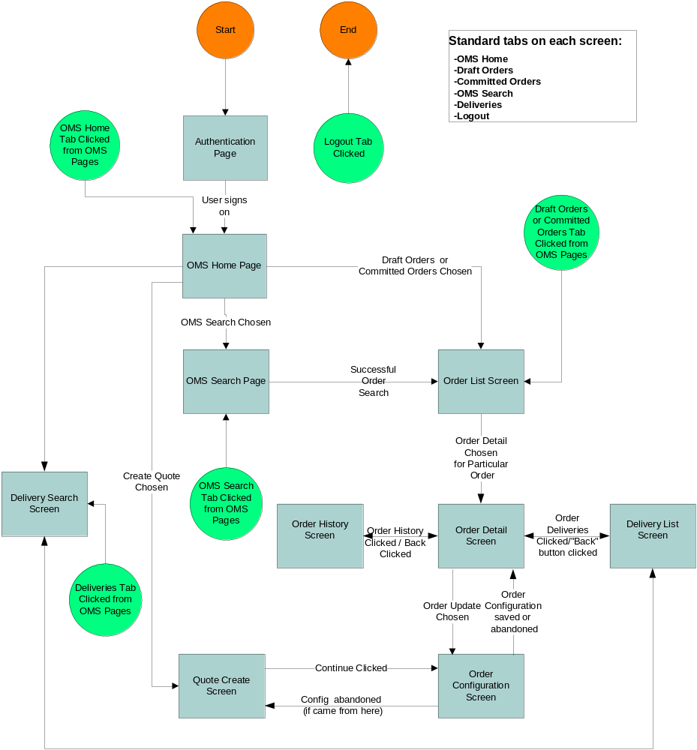
Figure 1: OMS Screen Flow

Standard Tabs

Each screen will offer the tabs noted below which link to the noted screens. These will be located in a standard position in all screens as depicted in the mockups.

Button Name | Links To
OMS Home | OMS Home Page
Draft Orders | Order List Screen (showing only Draft Orders)
Search | Order Search Screen
Committed Orders | Order List Screen (showing only Committed Orders)
Deliveries | Delivery Search Screen
Logout | OMS Authentication Screen
Help | Reserved for future iterations – help won’t be supported in the current iteration

Notes:
- The Help and Logout buttons will be on the upper right hand side of the screen per IRI standards and as noted in the mockups
- The Logout button won’t be displayed on the Authentication page (as the user wouldn’t yet be logged in at this point)
- The highlighting of tabs will change as the user navigates as follows:

From Screen | To Screen | Highlighted Tab
OMS Home | Order Create | Draft Orders
OMS Home | Any other than Order Create | Tab that corresponds to home page link

User Roles and Roles Based Functionality

A need for various roles which impact order visibility and availability of specific functionality has been identified. Since the Netegrity solution on which role identification will be built won’t be ready in the I2 timeframe, it was decided to limit the roles supported in I2 as follows:

Role / Function | Order Visibility | Accessible Functionality
Customer-Service | Only orders the user created | All functionality accessible except for Delivery Search
Administrator | All orders | All functionality accessible

Note: It was decided that in this iteration, there would only be one role. All users will have access to all functionality and all users will have access to all orders.

Concurrent Activity and Conflict Handling

The table above provides for scenarios whereby multiple users may be editing or canceling orders at the same time. There are also scenarios where back-end processes may be modifying data that is being accessed by the OMS. John West has agreed to an optimistic locking method of conflict handling for the OMS and related systems. The attached document notes this in more detail.

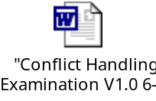

From an OMS application standpoint, the application will have to handle notification to users in the cases where there were external modifications to objects since they were retrieved and displayed that they attempt to perform operations on. The specific cases where this conflict handling logic needs to be implemented is noted below where applicable.

Note: Although implementation of conflict handling isn’t required for this iteration, it will be implemented in some areas where it would be easier to implement now rather than to retrofit.

Internationalization

There are future requirements outside for all text to be displayed in localized languages. Care will be taken to account for this in the design, although it won’t be implemented.

Screen M01: OMS Authentication Screen

Screen Profile
Screen Name | OMS Authentication Screen
Screen ID | M01
Screen Purposes | Entry point to the OMS system. Allows a user to login and be authenticated.
Screen Functionality | - Provides a login and password field  - Authenticates users and proceeds to OMS Home Page if user is successfully authenticated  - Maps the current user to a supported OMS role  - Tells user if login failed and allows users to retry failed logins
Screen Accessible from | Screen ID | Conditions of Accessibility
Intranet | N/A | When the user enters the address of the screen in his/her browser
Screen Links to | Screen ID | Conditions of Accessibility
Order List Screen | O04 | After the user has been authenticated

Authentication Screen Fields and Functionality

The Authentication Screen allows OMS users to be authenticated and provides mapping of users to OMS roles.

Note: Requirements regarding session timeouts have not been provided. In light of this, a softly configurable system-wide inactivity session timeout period will be set. When a session is inactive for this period of time, the session will time out and the user will have to re-login (with the next user interaction, a screen will be displayed noting that the session had timed out and providing a link to the login page). All work not saved up to this point will be lost.

Field ID / Type | Field Name | Description | Restrictions/Actions
M01-TF1 | User Name Field | Text field which allows the user to enter their login name | - Required field
M01-TF2 | Password Field | Text field which allows the user to enter their password | - Required field  - Asterisks displayed instead of password characters
M01-B1 | Login Button | Button which initiates the login | - Validates the user name/password via service that interfaces with LDAP. If the names are validated proceeds to the OMS Home Page. Otherwise, alerts the user that the login name or password was incorrect and allows the user to retry.  - Failure messages will be abstract (user won’t be told whether user name or password was incorrect)  - If there is an error in reaching the authentication service, the user will be notified of this in non technical terms and asked to retry later

Authentication Screen Mockup

A mockup of the Authentication Screen follows.

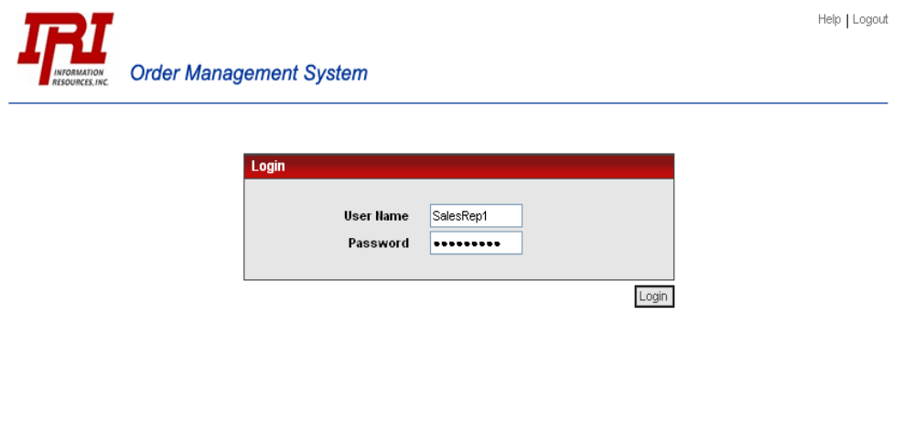
Figure 2: OMS Authentication Screen

Under the Hood: Authentication Service and Role Mapping

The Authentication Requirements Document specifies an authentication service that communicates with IRI’s LDAP server that will authenticate OMS users. It also specifies the inputs and outputs to this service as well as logging and other requirements. Please refer to this document for the specifics.

The Authentication Service will map users to an OMS role. Selectica will define the structure of a role table that maps roles to supported functionality (see role matrix above) and have responsibility for maintaining the role table.

Screen M02: OMS Home Page

Screen Profile
Screen Name | OMS Home Page
Screen ID | M02
Screen Purposes | Home page for OMS. Has links to key OMS screens.
Screen Ownership | IRI
Screen Functionality | - Has links to key OMS screens
Screen Accessible from | Screen ID | Conditions of Accessibility
Standard Links | Standard Tabs | When the user clicks on the OMS Home Page Standard Button
Screen Links to | Screen ID | Conditions of Accessibility
Order List Screen | O04 | When “Draft Orders” clicked
Order Search Screen | O03 | When “Order Search” clicked
Order List Screen | O04 | When “My Orders” clicked
Order Create Screen | O01 | When “Create Order” clicked
Order Delivery Search Screen | D01 | When “Order Delivery Search” clicked
OMS Authentication Screen | M01 | When “Logout” clicked

OMS Home Page Fields and Functionality

The fields and the functionality offered by the OMS Home Page are noted below.

Field ID / Type | Field Name | Description | Restrictions/Actions
M02-HL1 | Draft Orders Link | Link to the list of draft orders that the current user has created | Hyper-Link to the Order List Screen (O04) that only displays the draft orders that the current user created.
M02-HL3 | Committed Orders Link | Link to list of committed orders that the current user has created | Hyper-Link to the Order List Screen (O04) that only displays the committed orders that the current user created.
M02-HL2 | Order Search Link | Link to the Order Search Screen | Hyper-Link to the Order Search Screen (O03)
M02-HL4 | Create Order Link | Link to the Order Create Screen | Hyper-Link to the Order Create Screen (O01). When there is Siebel integration, this link will no longer reside on the OMS Home Page. Order creation will be initiated from within Siebel.
M02-HL5 | Order Delivery Search Link | Link to the Delivery Search Screen | Hyper-Link to the Order Delivery Search Screen (D01). Will only be available for certain roles (see role matrix above).

OMS Home Page Mockup

A mockup of the OMS Home Page follows

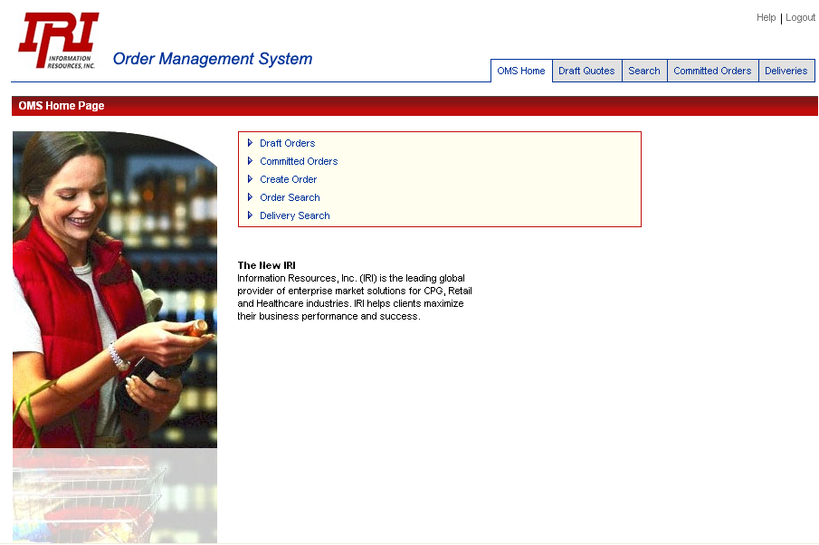
Figure 3: OMS Home Page

Screen O01: Order Create Screen

Screen Profile
Screen Name | Order Create Screen
Screen ID | O01
Screen Purposes | Allows a user to create a new order
Screen Functionality | - Allows the user to enter other pertinent information related to the order and to initiate creation of the order
Screen Accessible from | Screen ID | Conditions of Accessibility
OMS Home Page | M02 | When the user clicks on the “Create Order” link
Screen Links to | Screen ID | Conditions of Accessibility
Standard Links | Standard Tabs | User clicks standard link button
Order Configure Screen | O02 | When the user clicks on the Next button
OMS Home Page | M02 | When the user clicks on the Cancel button

Order Create Screen Fields and Functionality
The fields and the functionality offered by the Order Create Screen are noted below.

Field ID / Type | Field Name | Description | Restrictions/Actions
O01-PL1 | Country Pick List | Pick list of the country that the order is for | - List of supported countries
O01-PL2 | Client Pick List | Pick list of available clients | - List of available clients.  - The country determines the set of available clients.  - When the user chooses a client, the client ID and client types will be displayed next to the client field. *TODO*: Need to add to mockup
O01-UE1 | Order Name Text Field | Field which lets the name of the order be specified | - Maximum of 25 characters.  - May not include certain special characters which will not be allowed (i.e. angle brackets, etc…)
O01-PL3 | Order Type Pick List | Pick list of order types | - Can be Subscription or Ad Hoc
O01-PL4 | Product Pick List | Pick list of supported products | - Initially just InfoScan MK
O01-B1 | Continue Button | Allows the user to proceed to the Order Configure Screen | - Which clicked, a check will be made that all required info is filled in. If not, an error message will be displayed. If so, the Order Configure Screen will be accessed.  - Note: Nothing is saved when this page is exited – the first save will occur when the configuration is first saved
O01-B2 | Cancel Button | Allows the user to abandon the create order operation | - When clicked, an “are you sure” prompt will appear. If the user is sure, the order will not be created and the user will return to the screen that they came from
Standard Tabs | Standard Tab Buttons | Standard Tab Buttons | - If a user clicks on one of these buttons, he will be asked if he is sure as he will be abandoning the Order Create function.

Note: There are no requirements for functionality which allows a order name or any other information in the Order Create Screen to be changed once a order is created.

Order Create Screen Mockup

A mockup of the Order Create Screen follows.

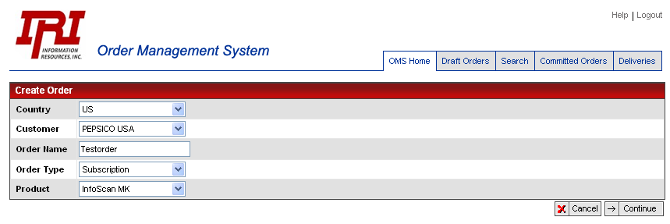
Figure 4: Order Create Screen

Screen O02: Order Configuration Screen

Screen Profile
Screen Name | Order Configuration Screen
Screen ID | O02
Screen Purposes | Allows users to configure/reconfigure order dimensions based on the product model
Screen Functionality | - Allows users to configure/reconfigure order dimensions based on the product model  - Allows users to commit (save) configuration settings/updates  - Allows the user to abandon configuration settings/updates  - Provides for validation of configuration dimension settings based on the product model’s rules and constraints
Screen Accessible from | Screen ID | Conditions of Accessibility
Order Create Screen | O01 | When the user chooses the “Create Order” function
Order Detail Screen | O05 | When the user chooses the “Update Order” function for a particular order.
Screen Links to | Screen ID | Conditions of Accessibility
Standard Links | Standard Tabs | User clicks standard link button. Note: If the user has made changes to a configuration, a popup will be displayed with any standard key choice asking the user if he/she is sure that he/she wants to abandon their changes.
Order Detail Screen | O05 | If the user had been reconfiguring an order and the user completes the configuration activities and saves the configuration or if the user came from the Order Detail Screen and abandoned the configuration update
Order Create Screen | O01 | If the user was creating a new order and had come from the Order Create Screen and abandoned the Order Create operation.

Order Configuration Screen Fields and Functionality

The Order Configuration Screen allows products to be configured based on the rules and constraints in the product model. A basic screen layout for the dimension classes and dimension items will be defined. The product model will define the behavior such as whether the dimension items are to be chosen as radio buttons, multi-select check boxes, drop downs, etc… The model will also define the constraints and rules that may prohibit particular selection combinations, enforce certain selections, or auto-select certain dimension items.

Configuration Panes

There will be two panes used in the configuration screen: the option item/option class pane and the configuration summary pane.

Option Item/Class Pane

The option item/class pane contains the option classes and dimension items for a particular option class (dimension class) where a user can choose particular option items. The option classes will be expandable and collapsible. When a particular option class is chosen, the option items for that option class will be displayed to the right of it and collapsing the option class that was previously expanded. Thus only one set of option items will be displayable at a time. Collapsible option classes were chosen since it is anticipated that there may be some option classes with a large number of option item.

Option Item/Class Pane Data Type Nesting
The InfoScan MK product has nesting at the data type level. The item dimension class is at the order level and shared amongst all data types. It will be displayed above the nesting section. There will be a tab for each of the data types (POS, Consumer, and TRV). When one of the tabs is clicked a full set of the other dimension classes will be displayed (measures, venues, deliveries, time periods). In each data type tabbed section will be a checkbox which allows the data type to be selected and deselected for inclusion into the order. The model will control rules such as which data types must be chosen with other data types and warnings when a data type is deselected (the warning in this case would be that all selections for a data type will be lost when a data type is deselected).

Configuration Summary Pane

The configuration summary pane contains a running summary of the option items that have been selected by users. When pricing is implemented, this pane will also include pricing information.

Configuration Summary Pane Data Type Nesting

The configuration summary pane will contain sections of dimension class sets for each data type that has been added to an order.

Model Dimension Option Classes

The Modeling System Design Document will address the product model including rules and constraints in more detail. The specific content of the option classes and the associated rules are beyond the scope of this document.

Note: The current interface works for the limited number of option items that we know of. It is anticipated that as more is known about the product models, some option classes will have large numbers of option items which result in the need for a different UI for selecting option items (i.e. filtering functionality).

Order Configuration Screen Fields and Functionality

The fields and the functionality offered by the Configuration Screen which are not related to the product model are noted below.

Field ID / Type | Field Name | Description | Restrictions/Actions
O02-B1 | Save Configuration Button | Button which allows current Order Configuration to be saved | - Only displayed if the user is configuring/reconfiguring a draft order  - The current configuration items will be validated per the product model. If there are configuration errors, they will be displayed to the user in a pop-up box and the user will have the option of correcting the configuration or canceling his changes (i.e. not saving).  - If the configuration is valid, an “are you sure” popup will appear. If the user isn’t sure, the save operation will be aborted and the user will return to the configuration screen  - Conflict Handling: As noted above in the conflict handling section, If the order has been modified by someone else since it was bought up, a popup will be displayed to the user noting that someone modified the configuration. When the user clicks on a continue button on the dialog, the configuration will be reread and redisplayed.  - The current configuration will be saved and the Order Detail Screen will be displayed showing the updated configuration information.
O02-B2 | Commit Order Button | Button which allows current order configuration to be saved (updated) | - Only displayed if the user is updating (reconfiguring) an order  - The current configuration items will be validated per the product model. If there are configuration errors, they will be displayed to the user in a pop-up box and the user will have the option of correcting the configuration or canceling his changes (i.e. not saving).  - If the configuration is valid, an “are you sure that you want to update this order” popup will appear. If the user wasn’t sure he will return to the configuration screen and the save operation will be aborted. If the user was sure:  - A popup will appear which allows the user to enter a comment for the order  - This field must be filled in for updated orders and fill-in is optional for newly committed orders  - Standard special character filtering rules apply  - The user will have the ability to abort the save operation from this popup  - Conflict Handling: As noted above in the conflict handling section, the timestamp of the configuration and order will be reread before the save. If it had changed, a popup will be displayed to the user noting that someone modified the configuration. When the user clicks on a continue button on the dialog, the configuration will be reread and redisplayed. If the configuration’s status had changed to committed or had been cancelled, the screen will be updated appropriately.  - The updated order will be saved as a new version (copy) of the order will be saved with the new updated configuration information  - The old order (pre modified version that was the active order) will be marked as “Updated” and will in effect be cancelled by the back-end service.  - The order update service API call will be made to update the order on the back end  - The new order will contain a reference to the original order (the first original version of the order that was created – not the prior version that was updated)  - The Order Detail Screen will be displayed with the updated order information.
O02-B2 | Cancel Button | The name of the order line item that was given by the user when creating the order | - An “are you sure” popup will appear. If the user is sure, his changes will be abandoned, and he will return to the Order List Screen.
O02-B3 | Verify Button | Allows a configuration to be verified for completeness and correctness based on the product model | - Performs checks based on the model which are a function of completeness or intra-option class/item rules

Order Configuration Screen Mockup

A mockup of the Order Configuration Screen follows.

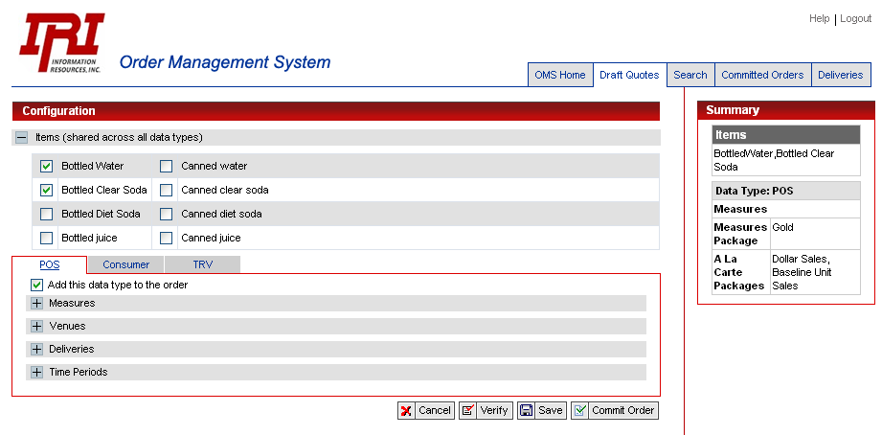
Figure 5: Order Configuration Screen

Screen O03: Order Search Screen

Screen Profile
Screen Name | Order Search Screen
Screen ID | O03
Screen Purposes | Allows orders to be searched for
Screen Ownership | Selectica
Screen Functionality | - Allows orders to be searched for and accessed
Screen Accessible from | Screen ID | Conditions of Accessibility
Standard Links | Standard Tabs | When the user clicks on the Order Search standard button
Screen Links to | Screen ID | Conditions of Accessibility
Standard Links | Standard Tabs | User clicks standard link button
Order List Screen | O04 | When the search finds orders that match the search criteria entered by the user (this is displayed underneath the search screen)

Order Search Screen and Functionality

The fields and the functionality offered by the Order Search Screen are noted below.

Functional Notes:

- If there are no matches, a message noting this will be displayed (popup ok)

- The number of pages of matches will be displayed with each search result

- If there are matches, the matches will be displayed on the Order List Screen (O04). The Order List Screen will be displayed underneath the Order Search Screen contents (see Order List Screen mockup).

- Searches will be a logical “and” of all of the fields that are filled in with the exception of the Order ID field. This field will be the only ones considered if it is filled in. Only the number of characters that are filled in will be considered as a leading character search (i.e. “J” will find Joe and John and “Joh” will find John and Johnny.

- All text searches will be case insensitive

- Searches will abide by visibility rules (i.e. users will only see matches that meet their visibility rules)

Constant Search Fields

The following fields are displayed regardless of which dimension group button is clicked.

Field ID / Type | Field Name | Description | Restrictions/Actions
O03-RB1 | Search Type Radio Button | Allows user to choose a draft vs. committed order search | - Radio button with title of “Search” that has 2 values: Draft Orders and Committed Orders
O03-B1 | Dimension Group Level Button | Button which allows the Dimension Group Level search fields to be displayed | - Has 2 states: highlighted and unhighlighted. Clicking alternates the states  - When highlighted, the Dimension Group Level search fields will be displayed under the order level search fields (see below)  - This button will be highlighted when active and the Dimension Group Level fields are displayed and unhighlighted otherwise.  - When unhighlighted the dimension group level fields will be hidden
O03-B2 | Dimension Detail Level Button | Button which allows the Dimension Detail Level search fields to be displayed | - Inoperable in this iteration – usage reserved for future iterations
O03-B1 | Search Button | The button that invokes the search. | - See notes above for behavior
Standard Navigation Buttons | Standard Navigation Buttons | Standard Navigation Buttons | - Home Page, Draft Orders, Committed Orders, and Order Search links

Order Level Search Fields

The following order level search fields are displayed regardless of which dimension group button is clicked.

Field ID / Type | Field Name | Description | Restrictions/Actions
O03-TF1 | Order ID | The ID of the order that is being search for | - Exact non-wildcard search that will result in either 0 or 1 found result.  - If the user enters anything in this field, they should be prevented from entering anything else in any other fields as this search stands alone (can be via run-time JavaScript or at submit time)
O03-TF2 | Client ID | The ID of the client of the order that is being searched for | - None
O03-TF3 | Client Name | The name of the client of the order that is being searched for | - None
O03-TF4 | Order Name | The name of the order that is being searched for | - None
O03-PL1 | Product Pick List | Pick list that contains the product that is being searched for | - Contains the full set of supported products

Dimension Group Level Search Fields

The following dimension group level search fields are displayed only when the dimension group level button is highlighted (see above). Searches on these fields will find the orders that have the specified dimension value settings.

Field ID / Type | Field Name | Description | Restrictions/Actions
O03-PL2 | Data Type Pick List | Pick list of data types | - Set to POS, Consumer, or TRV
O03-PL3 | Delivery Schedule Pick List | Pick list of schedules | - Set to defined set of schedules
O03-TF5 | Measure ID | Measure ID | - None
O03-TF6 | Venue Group ID | Measure ID | - None

Order Search Screen Mockup

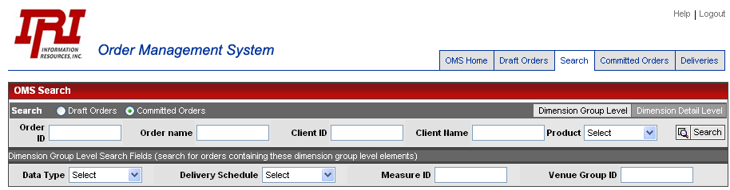
Figure 6: Order Search Screen

Screen O04: Order List Screen

Screen Profile
Screen Name | Order List Screen
Screen ID | O04
Screen Purposes | Displays the set of draft or committed orders created by the current user when he/she clicks on the “Draft Orders” or “Committed Orders” tab and us used to display search results
Screen Functionality | - Displays set of orders created by the current user  - Displays order search results
Screen Accessible from | Screen ID | Conditions of Accessibility
Standard Tabs | Standard Tabs | When the “Draft Orders” or “Committed Orders  standard buttons are clicked
Order Search Screen | O03 | When the user performs a successful order search
Screen Links to | Screen ID | Conditions of Accessibility
Standard Links | Standard Tabs | User clicks standard link button
Order Detail Screen | O05 | When the user clicks on the Order Detail Button for a particular order
Order Search Screen | O03 | When the wants to search again (is concatenated on top of the Order List Screen)

Order List Screen Fields and Functionality

The Order List Screen supports the following functions:

- Displays the set of orders created by the current user when he/she clicks on the “Draft Orders” or “Committed Orders” tabs
- Displays the set of orders as a result of an order search (see Screen O03: Order Search Screen).
  - When displaying the results of a order search, the Order List Page components will be displayed underneath the Order Search Screen components (see mockup below)
- Provides sorting and pagination functionality

The information displayed for each order is the same in both cases. The only difference has to do with navigation and title information.

Differences In between Draft and Committed Orders

The Order List Screen displays both Draft and Committed Orders although not both at the same time. There are some differences in between what is displayed for draft vs. committed orders as follows:

Only For Draft Orders | Only For Committed Orders | Reason for Difference
Date and Time of Last Update | Date and Time of Order Submission | Once an order is submitted, when modified, a new order will be created and thus the date and time of order submission will indicate modification information
Who Last Updated Order | Order Submitter | Once an order is submitted, when modified, a new order will be created and thus the order submitter will indicate the person who last modified a committed order.
Draft Order Version # |  | Versions may only be created for draft orders.

The following fields are displayed at the page level (vs. the order line item level):

Field ID / Type | Field Name | Description | Restrictions/Actions
O04-DF1 | Screen Title | The title of the screen | - If the screen was accessed as a result of the user clicking on the “Draft Orders” button, the title reads, “Draft Orders”  - If the screen was accessed as a result of an Order Search, the title reads, “Search Results”
O04-PL1 | Order Status Pick List | Pick list that allows the types of orders that are to be displayed to be specified | - Has the following values: All, Draft, New, In Progress, Complete, and Cancelled.  - The value “All” will never include draft and non draft orders since searches will never permit both to be displayed at the same time.  - When the user changes a the order status item, the current Order List will change based on the new choice  - If the user is viewing “Draft Orders” or “Committed Orders” this list will change – if he is viewing search results, the search results will change based on the prior search).  - If there are no orders meeting the new order type constraint, a message will be displayed noting this.
O04-B2, B3 | Next Page/Previous Page Buttons | Pagination Buttons | - See pagination section below
O04 B4…BX | Sorting Buttons | Column level sorting buttons | - See sorting section below.
O04-UE1 | Rows Per Page | Allows the user to specify the number of rows per page | - Must be from 2-99  - See pagination section below
Standard Tabs | Standard Links | Standard links that are displayed on all pages | - Page that link references is accessed

The following fields are displayed for each order:

Field ID / Type | Field Name | Description | Restrictions/Actions
O04-DF2 | Order ID | The ID of the order. | - Each order will be assigned a unique ID when it is first saved
O04-HL1 | Order Name | Name of the order. Hyper-Link to the Order Detail Screen | - Hyper-Link to the Order Detail Screen (O06) for this order
O04-DF3 | Client | The name of the client (customer) | - None
O04-DF4 | Creator | The name of the user who created the order | - The name of the current user will be provided by the Authentication Service (needs to be retained by the OMS application)
O04-DF5 | Last Update Date and Time | Date and time that the configuration was created or last updated | - In Iteration1, all dates will be displayed in the time zone of the server which is assumed to be CST.  - This will only be displayed for draft orders since a new order is created for modified submitted orders and the Order Submitted Date and Time field will contain relevant modification information
O04-DF6 | Updated By | The name of the user who last updated the order | - The name of the current user will be provided by the Authentication Service (needs to be retained by the OMS application  - This will only be displayed for draft orders
O04-DF7 | Order Version# | The version number of the current order | - New orders start out with version 1 and are incremented by 1 with each new version
O04-DF8 | Order Submitter | The name of the person who submitted the order | - Will be the name of the user who last updated the order in the case of an updated submitted order  - This will only be displayed for committed orders
O04-DF9 | Order Submit Date and Time | The time that the order was submitted | - All dates and times will be displayed in the time zone of the server which is assumed to be CST.  - This will only be displayed for committed orders
O04-DF8 | Order Status | The current state of the order | The set of states supported (these definitions are directly from the requirements document):  - Draft: order hasn’t been submitted to the ordering system.  - New: Order has been submitted. Today’s date is less than first delivery date.  - In Progress: Today’s date is greater than first delivery date and less than last delivery date.  - Complete: Today’s date is greater than last delivery date.  - Cancelled: The order has been cancelled  Per one of the assumptions noted above, it is assumed that an external entity will keep the order record statuses up to date.

Order List Screen Pagination Functionality

The Order List Screen will offer pagination functionality as follows:

- A field on the screen will allow users to choose how many rows they want to see on a page (see mockup).
  - This will default to 15 rows
  - The value that the user chooses will remain for all list screens throughout the current session
  - Nice to have: The value that a user chooses will be saved with a profile that is retrieved with the next session (i.e. saved in a cookie)

- There will be an indicator at the top of the screen which notes the current page number and how many pages of orders there are (i.e. Page 2 of 5).

- There will be “next page” and “previous page” images/buttons (i.e. arrows) which allow users to access the next and previous pages. These images will be grayed out if there is no prior and/or next page. If it is easier to implement, we can just not display them if there is no next and/or prior page.

- When the user clicks on the next/previous page icon, the page of orders will decrease/advance.

- There will be a “go to first page” and “go to last page” which respectively go to the first and last page of the current view.

Order List Screen Sorting Functionality

The Order List Screen will offer sorting functionality as follows:

- Each column field will have an arrow indicator and down arrow indicator which allows the current field to be sorted (see snippet below from GEMS app).

- If the user clicks on the down arrow button, all orders will be sorted descending by that field. If the user clicks on the up arrow button, all orders will be sorted ascending by that field.

- Sorting will be global for the current order result set and not for only the current page (i.e. if there are 3 pages, sorting will be across all 3 pages and not just for the current page.

- Column sorting settings should be remembered within the current session (i.e. if a user changes the sorting setting to date/ascending, this setting should remain within a session until the user changes it.

  - Nice to have: Sorting sessions are remembered across sessions (i.e. saved in a cookie so that they are retained in the next session).

Order List Screen Mockup

Various invocations of the Order List Screen follow.

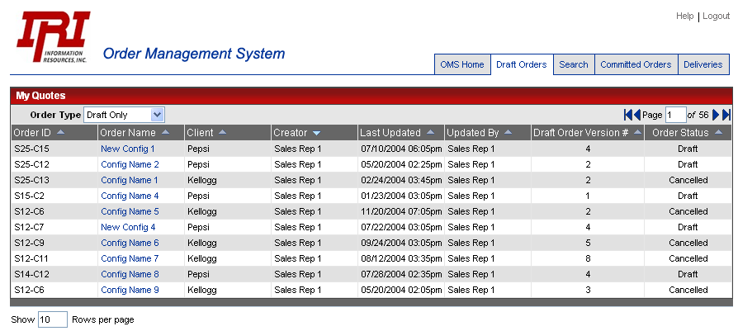
Figure 7: Order List Screen – Draft Orders

Figure 8: Order List Screen – Committed Orders

A mockup of the Order List Screen displayed as a result of a order search is below.

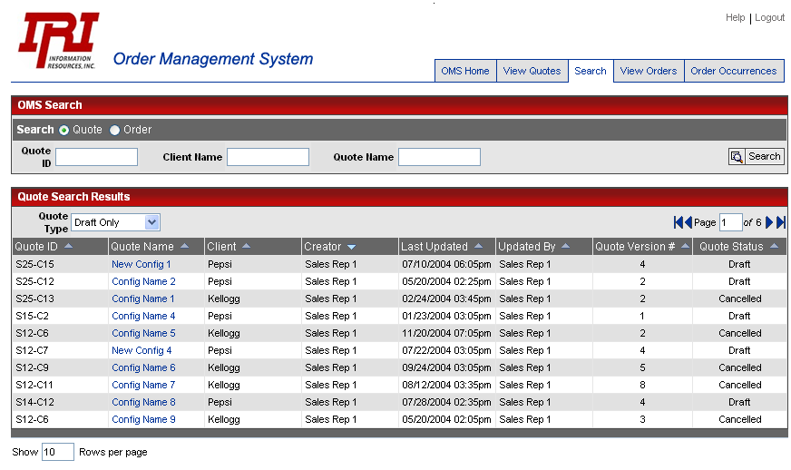
Figure 9: Order List Screen – Order search

Screen O05: Order Detail Screen

Screen Profile
Screen Name | Order Detail Screen
Screen ID | O05
Screen Purposes | Provides the details of an order and initiation point for other order related functionality
Screen Functionality | - Provides a view of the details of an order  - Allows orders to be updated (reconfigured)  - Allows orders to be cancelled  - Entry point to the Delivery List Screen which displays the deliveries associated with the current order  - Entry point to the Order History Screen (for committed orders)  - Entry point to the Draft Order Version History Screen (for draft orders)
Screen Accessible from | Screen ID | Conditions of Accessibility
Order List Screen | O04 | When the user clicks on the order name hyper-link
Order History Screen | O07 | When the user clicks on a particular order from the order history screen
Screen Links to | Screen ID | Conditions of Accessibility
Standard Links | Standard Tabs | User clicks standard link button
Order Configuration Screen | O02 | When the user clicks on the Update Order Button
Order History Screen | O07 | When the user clicks on the Order History Button
Order Delivery List Screen | D02 | When the user clicks on the Order Deliveries Button
Draft Order Version History Screen | O06 | When the user clicks on the Version History Button for a draft order

Differences In between Draft and Committed Orders

The Order Detail Screen displays both Draft and Committed Orders There are some differences in between what is displayed for draft vs. committed orders as follows:

Only For Draft Orders | Only For Committed Orders | Reason for Difference
Draft Order Versions Button | Order History Button | There are versions for committed orders.
Submit Order Button | Order Submitted By  Order Submit Date and Time | Submitted order have already been submitted and only draft orders wouldn’t have yet been committed
New Version Button |  | Versions are only relevant to draft orders
Order Version # |  | Versions are only relevant to draft orders
 | Order Deliveries Button | There are no deliveries for draft orders

Order Detail Screen Fields and Functionality

The fields and the functionality offered by the Order Detail Screen are noted below.

Field ID / Type | Field Name | Description | Restrictions/Actions
O05-DF1 | Order ID | The ID of the order. | - Each order will be assigned a unique ID at order submittal time (returned by service which creates the order)
O05-DF3 | Order Name | The name of the order | - The name that was given by the user
O05-DF4 | Client Name | The name of the client | - None
O04-DF5 | Order Version # | The version number | - Only displayed for draft orders
O05-DF6 | Order Type | The type of the order | - The type of the order set when the order was created
O05-DF7 | Order Creator | The name of the user who created the Order | - None
O05-DF8 | Order Submitted By | The name of the user who submitted the order | - A service will be provided by IRI which returns the name of the current logged in user which will provide this information at order submittal time.
O05-DF9 | Order Submit Date and Time | The date and time that the order was submitted | - Only available for submitted orders
O05-DF10 | Order Status | The current status of the order | - The status of the order. See order status section above for a list of the statuses
O05-DF11 | Cancellation Comment | The comment that the user entered when canceling the order | - This field will only be displayed if the order has a status of cancelled. It will contain the comment that the user entered when the cancelled the order.  - This field is separate from the order comment field so that the order comment isn’t lost upon cancellation.
O05-DF12—DFX | Order Configuration Dimensions | The Dimension components that were selected by the user during order line item configuration | - Each option class and dimension item that the user chose/configured will be displayed.
O05-B1 | Update Order Button | Button that allows the current order to be reconfigured (edited) | - Link to the Order Configuration Screen (O02) to allow the user to change the configuration. See this screen for a description of the actions when an order is updated.  - Will not be displayed for orders which have a status of orders with a status of Cancelled or Closed.  - Not displayed for prior order versions (if accessed from the Order History Screen)
O05-B2 | Cancel Order Button | Button that allows the current order to be cancelled. | - This button will only appear for orders that have a status of New or Open (i.e. not available orders with a status of Cancelled or Completed and the only for the current draft order version.  - Which clicked, an “Are you sure” prompt appears to allow the user to confirm the cancellation  - If the user is sure, a popup will appear which allows the user to enter a cancellation reason.  - This is a required field which must have text in it  - Standard special character filtering rules will apply  - The user should have the opportunity to abort the cancellation from this popup  - When an order is marked as cancelled, a call will be made to an order-side service that will perform the back-end activities associated with this action. This includes cancellation of all deliveries that had yet to be run (See Requirements Document for more details)
Q03-B3 | Commit Order Button | Button that allows the order to be submitted to the order management system | - Only available for Draft orders  - When clicked, an “Are you sure” prompt will appear.  - If the user was sure, the Order Configuration will be validated against releaseability constraints. If there is a violation, the user will be notified (clearly in non technical terms) as to why he/she can’t submit the order by a popup and the order detail screen will be returned to. ).  - The configuration information will be provided to the Order Management-Order Create service that will be which will write order record(s) in the order table(s)  - The order detail screen will be displayed showing the new order’s details and the status of New
O05-B4 | Order Deliveries Button | Button that allows the deliveries for the current order to be displayed | - When clicked, the Order Delivery List Screen (D02) will be displayed for the current order (the deliveries of the currently displayed order)  - Not available for draft orders
O05-B5 | Order History Button | Button that allows the order history to be displayed | - When clicked, the Order History Screen (O07) will be displayed for the current order
O05-B6 | Copy Order Button | Button that allows for an order to be copied. | - When clicked, a dialog box will come up which will let the user name the order.  - The same restrictions that are on order naming will apply  - There should be some text on the dialog for committed orders which makes it clear to the user that they will be copying the order to a draft order (i.e. The contents of this order will be copied to a draft order. After the copy, you will be bought to the Order Summary Screen from where you can edit and/or submit the order copy as an order”)  - When the user clicks OK on the dialog box, the order will be copied  - The user will be bought to Order Detail Screen will be drawn showing the new copy  - Committed orders will be copied as draft orders.
Q03-B7 | New Order Version Button | Button that allows a new draft order version to be created | - Only available for draft orders  - When clicked, a confirmation dialog will appear (i.e. are you sure you want to create a new version?). Upon affirmation:  - A new version of the order (a copy) will be created with the version number incremented by 1. This order will have a status of Draft  - The current order would no longer be displayed on the Order List screen and would be replaced by the new version.
Q03-B8 | Rename Order Button | Allows for an order to be renamed | - When clicked, a popup will appear that asks the user for the new order name and which has an OK and Cancel button.  - The same rules for the rename will apply as for the original naming (see Order Create Screen)  - If the user clicks on Cancel, the operation will be aborted and the Order Detail Screen will be returned to  - If the user clicks on “OK”, the order will be renamed as noted and the Order Detail Screen will be redrawn depicting the new name. **TODO** Add Rename Button to Mockup
Q03-B9 | Version History Button | Button that is adjacent to each order in the Order List that has a status of Draft, Ordered, or Cancelled which allows version history of the order to be displayed | - Only available for draft orders  - When clicked, the draft order version history screen will be displayed for the current order (see O06)

Order Detail Screen Mockup

Mockups for the Order Detail Screen follow.

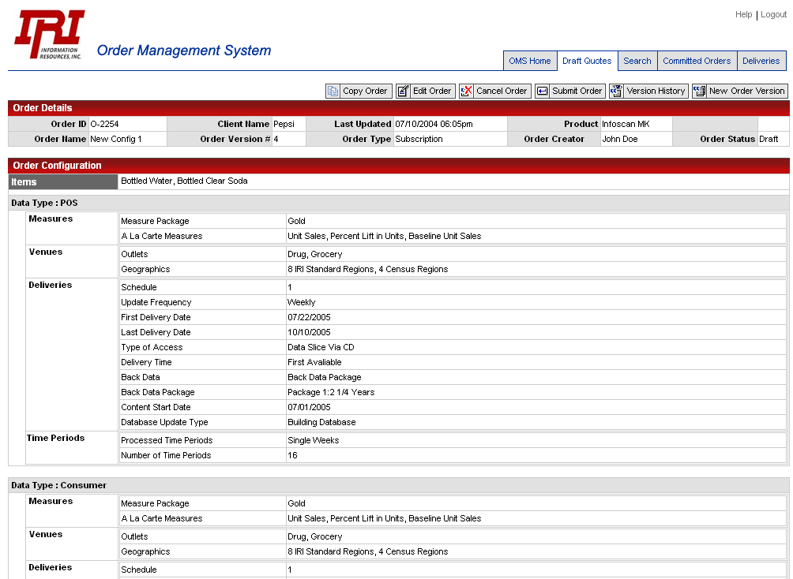
Figure 10: Order Detail Screen: Draft Order

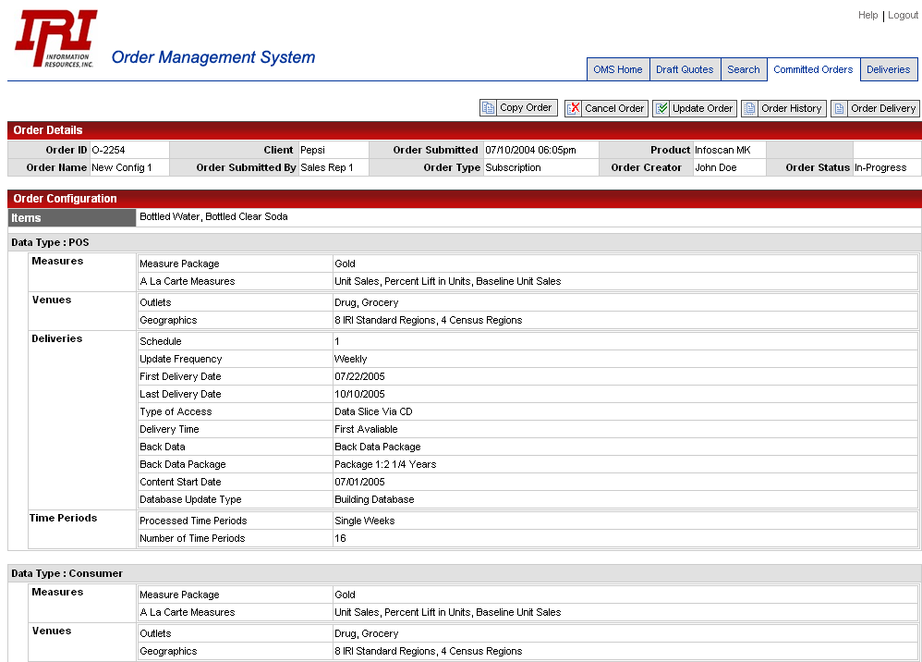
Figure 11: Order Detail Screen: Committed Order

Screen O06: Draft Order Version History Screen

Screen Profile
Screen Name | Draft Order Version History Screen
Screen ID | O06
Screen Purposes | Provides a list of all of the versions for a particular draft order
Screen Ownership | Selectica
Screen Functionality | - Provides a list of all of the versions for a particular draft order  - Allows prior versions of draft orders to be viewed
Screen Accessible from | Screen ID | Conditions of Accessibility
Order Detail Screen | O05 | When the user chooses the “Order Version” function.
Screen Links to | Screen ID | Conditions of Accessibility
Order Detail Screen | O05 | When the user clicks on the Order Name hyper-link for a particular order version

Draft Order Version History Fields and Functionality

The Draft Order Version History Screen is a variant of the Order List Screen (O04). It contains all of the display fields of this screen along with the Order Name hyper-link to the Order Detail Screen for each version that allows that version to be displayed. It also contains a Back Button that allows the Order Detail Screen to be returned to.

Notes:
- Orders in the Version History Screen will be ordered by default by the order version (ascending order)

- Pagination and Sorting functionality isn’t required on this screen (there shouldn’t be more than a handful of versions – isn’t necessary)

- Order versions other than the current version that are retrieved in the Order Detail Screen are only displayable – no other functionality may be performed on these (see Order Detail Screen description)

- This functionality is only available for Draft orders

Order Version History Mockup

A mockup of the Order Version History Screen follows.

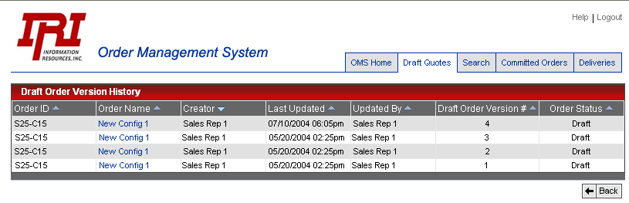
Figure 12: Version History Screen

Screen O07: Order History Screen

Screen Profile
Screen Name | Order History Screen
Screen ID | O07
Screen Purposes | Displays the history of orders
Screen Functionality | - Shows the history of orders
Screen Accessible from | Screen ID | Conditions of Accessibility
Order Detail Screen | O05 | The user clicks on the Order History Button
Screen Links to | Screen ID | Conditions of Accessibility
Standard Links | Standard Tabs | User clicks standard link button
Order Detail Screen | O05 | The user clicks on the “Back” button or when the user clicks on the order ID link for a particular order item

Order History Screen Fields and Functionality

The Order History Screen is a variant of the Order List Screen (O04). It contains all of the display fields of this screen along with the Order Name hyper-link to the Order Detail Screen for each version that allows that version to be displayed. It also contains a Back Button that allows the Order Detail Screen to be returned to.

Notes:
- Orders in the Order History Screen will be ordered by the date of the order modification (ascending order)

- Pagination and Sorting functionality isn’t required on this screen (there shouldn’t be more than a handful of versions – isn’t necessary)

- Order versions other than the current version that are retrieved in the Order Detail Screen are only displayable – no other functionality may be performed on these (see Order Detail Screen description)

Order History Screen Mockup

A mockup of the screen hasn’t been provided since it is a variant of the Order List Screen.

Screen D01: Order Delivery Search Screen

Screen Profile
Screen Name | Order Delivery Search Screen
Screen ID | D01
Screen Purposes | Allows users with appropriate roles to search for order deliveries
Screen Functionality | - Allows deliveries to be searched for
Screen Accessible from | Screen ID | Conditions of Accessibility
OMS Home Page | M02 | When the Order Delivery Search button is clicked
Screen Links to | Screen ID | Conditions of Accessibility
Standard Links | Standard Tabs | User clicks standard link button
Order Delivery List Screen | D02 | When a search is made that results in some found deliveries

Order Delivery Search Screen Fields and Functionality

The fields and the functionality offered by the Order Delivery Search Screen are noted below.

Functional Notes:

- The search will be a logical AND of all of the search fields in which data was entered or selections were made

- If there are no matches, a message noting this will be displayed (popup ok)

- Searches will abide by visibility rules (i.e. users will only see matches that meet their visibility rules)

  - Visibility rules for deliveries will be derived from those orders (i.e. if you can see see the orders, you can see their deliveries)

- Search results will be displayed in the Delivery List Screen (D02)

- There are requirements for searching for deliveries by order ID and order name. These requirements are met via the Show Deliveries button which is available from the Order Detail Screen. A user can search for orders using order ID or order name as criteria and see the deliveries from the Order Detail Screen.

Field ID / Type | Field Name | Description | Restrictions/Actions
D01-PL1 | Product Name Pick List | Product name search field | - Pick list of the set of products  - Defaults to “—Select—“ which indicates no choice  - Trailing Wildcards may be used  - Not spec’ed as a pick-list as there is an assumption that the ultimate number of products would to too large for a pick list (this assumption may turn out to be incorrect)
D01-PL2 | Delivery Status Pick List | Delivery state search field | - Pick list of the set of delivery statuses (see Delivery List Screen below)  - Defaults to “—Select—“ which indicates no choice
D01-TF1 | Client Name | Client name search field | - Trailing Wildcards may be used  - Not spec’ed as a pick-list as there is an assumption that the ultimate number of clients would to too large for a pick list
D01-CAL1 | Start Date, Date Range Field | Start date range calendar field | - Calendar field (JavaScript that allows calendar navigation and choice)  - Along with End Date Range Field considered a grouping which will search for deliveries starting at the start date and up until and including the end date. The date of the delivery is based on the delivery date of the delivery.  - Date must be chosen or an error message will appear  - Must be before or equal to the end date
D01-CAL2 | End Date, Date Range Field | End date range calendar field | - Calendar field (JavaScript that allows calendar navigation and choice)  - Along with Start Date Range Field considered a grouping which will search for deliveries starting at the start date and up until and including the end date  - Date must be chosen or an error message will appear  - Must be after or equal to the start date
O03-B1 | Search Button | The button that invokes the search. | - See notes above for behavior
Standard Navigation Buttons | Standard Navigation Buttons | Standard Navigation Buttons | - Home Page, Draft Orders, Committed Orders, and Order Search links

Order Delivery Search Screen Mockup

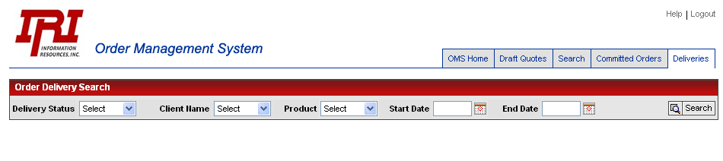
Figure 13: Order Delivery Screen

Screen D02: Order Delivery List Screen

Screen Profile
Screen Name | Order Delivery List Screen
Screen ID | D02
Screen Purposes | Displays the set of deliveries either associated with an order or as a result of an delivery search
Screen Functionality | - Displays the set of deliveries associated with an order  - Displays the set of deliveries as a result of an delivery search
Screen Accessible from | Screen ID | Conditions of Accessibility
Order Detail Screen | O05 | When the Deliveries button is clicked
Order Deliveries Search Screen | D01 | When deliveries are found from the user’s search criteria
Screen Links to | Screen ID | Conditions of Accessibility
Standard Links | Standard Tabs | User clicks standard link button
Order Detail Screen | O05 | When the user clicks on the Order Name link from an order delivery item or when the user clicks “Back” and had come from the Order Detail Screen
Order Deliveries Search Screen | D01 | When the user has come from the Order Deliveries Screen and clicks on the “Search Again” button.

Order Delivery List Screen Fields and Functionality

The following Order Delivery List Screen fields are displayed at the page level (vs. the order delivery line item level):

Field ID / Type | Field Name | Description | Restrictions/Actions
D02-DF1 | Screen Title | The title of the screen | - If the screen was accessed as a result of the user clicking on the “Order Deliveries” button from the Order Detail Screen, the title reads, “Deliveries for Order “Order Name”  - If the screen was accessed as a result of an delivery search, the title reads, “Order Delivery Search Results” (Nice to have: a notation of what the search criteria was).
D02-B1 | Search Again Button | A button that allows a new search | - Only displayed if the user has entered from the Order Delivery Search Screen  - Functions as a “Back” button that allows the user to refine his search criteria
D02-B2 | Back Button | A button that allows the user to return to the Order Detail Screen | - Only displayed if the user has entered from the Order Detail Screen  - Allows the user to return to the Order Detail Screen
D02-B3, B4 | Next Page/Previous Page Buttons | Pagination Buttons | - Functionality same as for Order List Screen (O04). Please refer to this section
D02 B5…BX | Sorting Buttons | Column level sorting buttons | - Functionality same as for Order List Screen (O04). Please refer to this section.
D02-CB1 | Rerun Checkbox | Checkbox that allows one or more deliveries to be selected for rerunning | - Will only be displayed next to each of the deliveries that may be rerun.  - Please refer to the Requirements Document for the rules which determine under which conditions an delivery may be rerun and what this entails (these are in a state of flux, so weren’t included here at this time). This will also address the rules for rerunning of cancelled and updated deliveries.
D02-B7 | Rerun Button | Button which allows the deliveries marked by the rerun checkbox to be run | - Initiates that a rerun is desired for all of the deliveries that have their rerun checkbox checked.  - When clicked a screen will be displayed which will:  - Summarize the deliveries that the user has selected for rerunning  - Have a rerun reason pick list (see requirements document for description of values).  - Have rerun reason sub-type pick list (see requirements document for description of values).  - Have a “Cancel” button which allows the users to cancel the rerun operation  - Have a “Perform Reruns” button that allows users to commence with the reruns. A check will be made that the user chose a rerun reason and rerun sub-type reason (if not, a popup will alert the users that they must do so  - If they confirm the rerun operation, the rerun service what performs the back-end rerun will be called for each of the checked deliveries (will probably have batch interface)  - The Delivery List Screen will be redrawn to reflect the updated delivery statuses due to the rerun operation.
Standard Tabs | Standard Links | Standard links that are displayed on all pages | - Page that link references is accessed

The following fields are displayed for each delivery.

Note: Only deliveries that are to run the current day or that have already been run are displayed. Future deliveries will not be displayed.

Field ID / Type | Field Name | Description | Restrictions/Actions
D02-DF2 | Delivery ID | The ID of the delivery | - Where this comes from has yet to be identified
D02-DF3 | Delivery Status | The status of the delivery | - The set of statuses has yet to be identified. It is assumed that there is an API that will be provided (by whom also not identified) that will provide a text string with the status
D02-DF4 | Delivery Delivery Date | The delivery date of the delivery | - None
D02-DF5 | Order ID | The ID of the order that the delivery belongs to | - None
D02-HL1 | Order Name Hyper Link | Name of the order that the delivery belongs to. Hyper-Link to Order Detail Page for that order | - None
D02-DF6 | Client Name | Name of the client of the order that the delivery belongs to | - None
D02-DF7 | Data Type | The data type that the delivery is associated with | - None
D02-DF7 | Product Name | The name of the product that the order that the delivery belongs to is for | - None
D02-DF8 | Delivery Content Start Date | The start date of the content of the delivery | - None
D02-DF9 | Delivery Content Start Date | The end date of the content of the delivery | - None
D02-DF10 | Rerun Date | The date that the delivery was rerun if it had been rerun | - If the delivery had been rerun, this is the date of the rerun (per the requirements, an delivery may only be rerun once)  - If the delivery hasn’t been rerun, this will display, “N/A”  **TODO** is this the actual rerun date or the planned rerun date?
D02-DF11 | Rerun Reason | The rerun reason that was given by the user if the delivery was rerun | - Only displayed if the delivery was rerun – blank otherwise
D02-DF12 | Rerun Reason Sub-type | The rerun reason sub-type that was given if the delivery was rerun | - Only displayed if the delivery was rerun – blank otherwise

Order Delivery List Screen Mockup

A mockup of the Order Delivery List Screen follows.
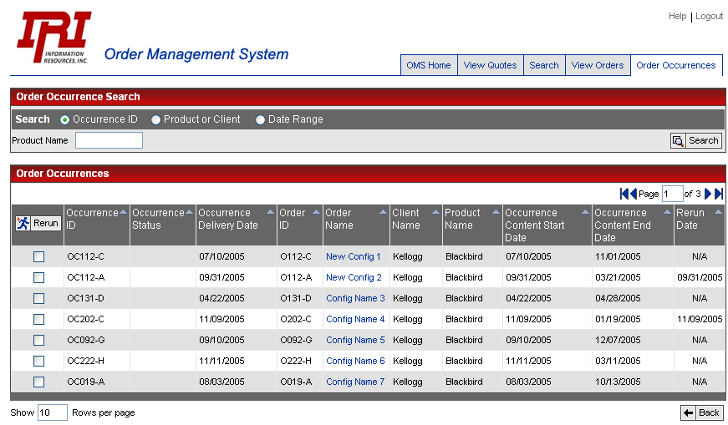
Figure 14: Order Delivery List Screen

This section could be filled in a bit more with additional assumptions. Will be beefed up in next version.
All orders are copied to new draft orders
A draft prior version may be copied to a new draft and the copy may be submitted
Although the capability exists to create a new current version from a prior version of a order, this functionality was specifically not requested.
Per Sarah Gibbs
It hasn’t been established as to whether multiple character sets will also need to be supported
The logout button shouldn’t be displayed on this page (erroneously in mockup)
Since this screen only has a couple of fields, a mockup hasn’t been provided. This screen should be consistent in format to other similar screens.
BOM structure is being discussed in a separate track. The conclusions and functional specification for this will either be released as a separate document or included in this document.

